5.4.1 Conic Sections (Parabolas)

If a plane passes through a double right circular cone there are four possible resulting curves. These curves are the parabola, circle, ellipse, and hyperbola. These curves are called conic sections and are shown below.
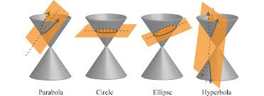

Definition: A parabola is the set of all points in the plane that are equidistant from a fixed line (the directrix) and a fixed point not on the line (the focus)

The Equation of a Parabola: (opening up or down)
The parabola

has focus

and directrix

Note: If then the parabola opens up. If then the parabola opens down.

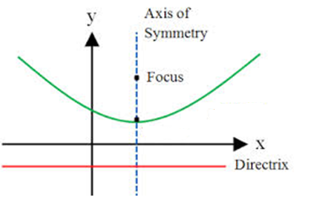

Example 1: Find the equation of the parabola with focus and directrix.

Example 2: Find the vertex, focus, and directrix of the graph of .

Example 3: Find the vertex , focus, and directrix of the graph of .

The Equation of a Parabola: (opening left or right)
The parabola

has focus

and directrix

Note: If then the parabola opens to the right. If then the parabola opens to the left..
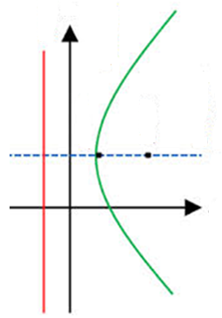

Example 4: Find the vertex, axis of symmetry, y-intercepts, focus, and directrix for the parabola . Sketch a graph of this parabola.

